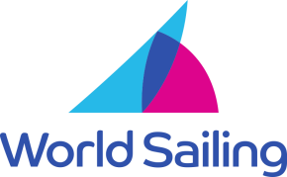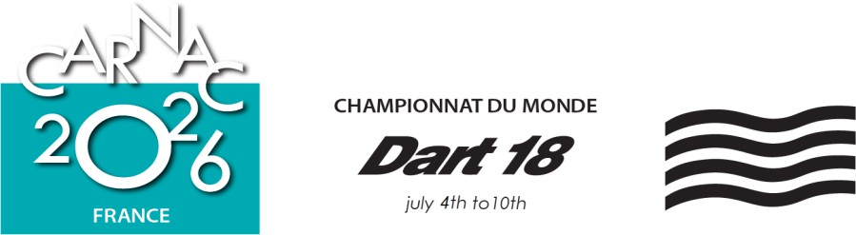
INTERNATIONAL JURY DECISION Case No: 3 With Case(s): 5 Race: 3

PARTIES
Boat or Committee or Person | Event | Represented By/Not Present
Race Committee |  | Alice Coquant
FRA 7883 |  | Cyril Biesse, helm
FRA 7646 |  | Lucie Teynie, crew

WITNESSES
Name | Boat – Committee - Role
Lucie Teynie | FRA 7646, crew

Case Summary:
Case 3: Protest alleging touching the mark.
Case 5: Protest alleging contact between boats.

Procedural Matters
- Yves Leglise, member of the International Jury, interpreted from French for FRA 7883

Validity:

Case 3
- The race committee posted on the ONB its intention to protest FRA 7883 and submitted its protest within the protest time limit.
- The protest in Case 3 is valid and the hearing proceeded.

Case 5
- The protest was delivered on 08 July at 11:10 am, well after the protest time limit on 07 July.
- FRA 7883 delivered her protest late because she did not know she was being protested.
- There was no good reason for the international jury to extend the time limit under RRS 60.3(b).

Facts found Case 3:
- The wind was 4 to 5 knots with flat seas.
- FRA 7883 was close-hauled on starboard tack, on a course to cross the starting line close aboard the RC vessel.
- FRA 7646 was reaching on port tack, passed ½ boat length astern of the RC vessel, and luffed onto a converging course with FRA 7883.
- FRA 7883 luffed slightly as FRA 7646’s bow came to within ¼ boat length of her. FRA 7646 continued to luff and passed head-to-wind.
- Contact occurred between FRA 7646’s starboard hull and FRA 7883’s port hull amidships.
- FRA 7648’s crew fended off the RC vessel.
- FRA 7883’s crew fended off the RC vessel.
- There was no damage or injury in the contact between FRA 7648 and FRA 7886 or with the RC vessel
- FRA 7648 took a one-turn penalty.

Conclusion & Rules:

Case 3
- After passing head to wind and before coming to a close-hauled course, FRA 7646 failed to keep clear of FRA 7883. FRA 7646 broke RRS 13.
- FRA 7646 did not avoid contact with FRA 7883 even though it was reasonably possible, and broke RRS 14(a).
- It was not reasonably possible for FRA 7883 the right-of-way boat to avoid contact with FRA 7646 when it became clear that FRA 7646 was not keeping clear. FRA 7883 did not break RRS 14.
- FRA 7883 touched the RC vessel and broke RRS 31.
- FRA 7648 caused contact between FRA 7883 and the RC vessel even though it was reasonably possible to avoid causing it, and broke RRS 14(c).
- Since FRA 7883 was compelled to break RRS 31 as a consequence of FRA 7646 breaking RRS 13 and 14(c), she is exonerated under RRS 43.1(a).
- FRA 7648 touched the RC vessel and broke RRS 31.
- FRA 7648 took an applicable penalty under SI 15.1 and RRS 44.1 for her breach of RRS 13, 14(a), 14(c) and 31.

Case 5
- FRA 7883 failed to inform FRA 7648 of the protest at the first reasonable opportunity as required by RRS 60.2(b)(3). Therefore, the protest is invalid under RRS 60.4(a)(1).

Decision:

Case 3
- The protest is upheld. Since FRA 7883 is exonerated by RRS 43.1(a) for her breach of RRS 31, no penalty is imposed on her.
Case 5
- The hearing of case 5 is closed under RRS 63.4(a)(1).

Protest Committee: International Jury: Yes
Chris Watts GBR IJ (Chair), Yves Leglise FRA IJ, Lynne Beal CAN IJ, Myrto Antonopoulou GRE IJ, Frank Brinkers GER IJ, Bruno Le Maître FRA NJ.

Signed: Chris Watts Date, time: July 8, 2026 21:00

