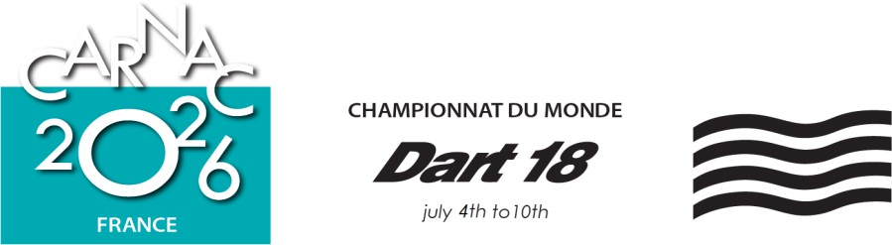
INTERNATIONAL JURY DECISION Case No: 4 With Case(s): Race: 3

PARTIES
Boat or Committee or Person | Event | Represented By/Not Present
BEL 7917 |  | Marc Van Hodgten

WITNESSES
Name | Boat – Committee - Role
Valid – Yes Submitted after racing within the protest time limit.

Case Summary: (type of Hearing and just brief introduction to help the reader)
Request for redress alleging damage caused by a boat required to keep clear

Procedural Matters

The international jury permitted BEL to correct the sail number of NZL from 7063 to 7066.

Facts found:
- The wind was 6 to 7 knots with flat calm seas.
- On the second downwind leg, BEL 7917 was reaching on starboard tack, with NZL 7066 on starboard tack ½ boat length ahead and one boat length to windward of BEL 7917.
- NZL 7066 gybed to port and came 5 metres ahead of BEL 7917.
- BEL luffed slightly toward NZL 7066’s stern.
- 3 seconds after NZL 7066’s gybe, contact occurred between BEL 7917’s port bow and NZL 7066’s rear beam, 1 metre from the transom.
- Damage to BEL 7917 was a through hole to her bow.
- NZL 7066 reported no damage.
- As BEL 7917 was taking on water, she retired from the race.
- NZL 7066 retired from race 3 and orally acknowledged fault in the incident.

Conclusion & Rules:
- NZL 7066 on port tack failed to keep clear of BEL 7917 on starboard tack, and broke RRS 10.
- NZL 7066 did not avoid contact with BEL 7917 even though it was reasonably possible, and broke RRS 14(a).
- Since NZL 7066 caused serious damage by her breach, her penalty was to retire as required by RRS 44.1(b).
- It was not reasonably possible for BEL 7917 the right-of-way boat to avoid contact with NZL 7066 when it became clear that NZL 7066 was not keeping clear. BEL 7917 did not break RRS 14.
- BEL 7917’s score in race 3 was made significantly worse through no fault of her own by physical damage because of the action of NZL 7066 that was breaking RRS 10 and 14(a) and took an appropriate penalty. Therefore, the requirements for redress in RRS 61.4(b)(2) are met.

Decision:
- Redress is given to BEL 7917. She is to be scored in race 3 points equal to the average, rounded to the nearest tenth of a point (0.05 to be rounded upward), of her points in all races sailed before the last scheduled day of the regatta if racing is later scheduled on that day, except race 3. No other boat’s score shall change.

Protest Committee: International Jury: Yes
Chris Watts GBR IJ (Chair), Yves Leglise FRA IJ, Lynne Beal CAN IJ, Myrto Antonopoulou GRE IJ, Frank Brinkers GER IJ, Bruno Le Maître FRA NJ.

Signed: Chris Watts Date, time: July 8, 2026 at 1930

