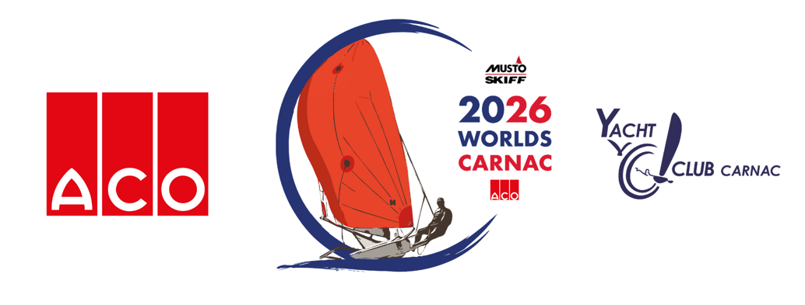
ACO MUSTO SKIFF WORLD CHAMPIONSHIP 2026,
YACHT CLUB DE CARNAC, 6-12 JUNE 2026

FINAL RESULTS PRESS RELEASE

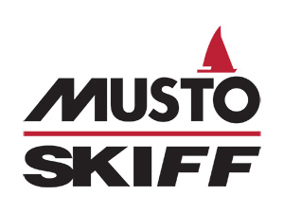
Rob Richardson Wins the ACO Musto Skiff 2026 Worlds Title

Report by Natalie Hilton

The class has had a fantastic week of sailing in Carnac for this year’s ACO Musto Skiff World Championship. It’s been an exciting championship with very close racing in the top 10, and equally close racing across the fleet, with many feeling the pressure of their own ambitions to top their categories.

This year, we had nearly 40 competitors representing eight nations, including France, Great Britain, Switzerland, Germany, the Netherlands, South Africa, Australia, and Armenia. The sailing conditions were excellent, if not a little breezy on some days, but everyone enjoyed the racing and sharing their stories of the day over beers in the warm sunshine outside the clubhouse of Yacht Club de Carnac.

Going into today, there were many battles to be won. Whilst the title win was looking like a certainty for overnight leader, Rob Richardson (GBR), nothing is certain until the final day is done, but Rob sealed it in the first race of the day to very deservingly take the World Championship title.

In the battle for second place, Eddie Bridle converted his third place into a second, overhauling Ben Clegg. In the battle for 4th, Euan Hurter outgunned Jamie Hilton to leapfrog him, with Jamie maintaining 5th and first master ahead of Dan Vincent in 6th. Another mention goes to the International Musto Skiff Class Chairman, Brennan Robinson, who on top of leading the organisation, secured his first top 10 finish at a Worlds with a storming last day to fend off Andy Rice! It was a tough fought day across the fleet in all categories to secure the podium positions.

However, after 5 days of racing and 14 races, it was Rob Richardson who maintained his lead and rounded out the event in style with the final race win to take the overall regatta and the 2026 ACO Musto Skiff World Champion Title!

Joining Rob on the podium was GBR sailor, Eddie Bridle, in 2nd place and GBR sailor, Ben Clegg, in 3rd place.

Well done all our competitors, with some travelling long distances to be here in Carnac for the regatta. Our top six places and category winners are as follows:
Top 6 Overall:
1st Rob Richardson (GBR), 2nd Eddie Bridle (GBR), 3rd Ben Clegg (GBR), 4th Euan Hurter (RSA), 5th Jamie Hilton (GBR), 6th Dan Vincent (GBR)
Youth – Top 3:
1st Rob Richardson (GBR), 2nd Tom Goodman (GBR), 3rd Will Homewood (GBR)
Master – Top 3:
1st Jamie Hilton (GBR), 2nd Dan Vincent (GBR), 3rd Dave Poston (GBR)
Grand Master – Top 3:
1st Brian Greensmith (GBR), 2nd Andy Rice (GBR), 3rd Wayne Bates (AUS)
Legend – Top 3:
1st Karsten Groth (NED), 2nd Richard Smith (GBR), 3rd Serega Photoskiff (GBR)
Silver – Top 3:
1st Karsten Groth (NED), 2nd Wayne Bates (AUS), 3rd Richard Smith (GBR)
1st Women:
Greta Müller (GER)
1st Mainsail X:
Greta Müller (GER)
The class would like to thank all the volunteers at Yacht Club de Carnac, the PRO and his excellent race team, the onshore team, our GPS trackers team, the media team, and all the local partners in Carnac.
And finally, a huge thank you to our main event sponsor, ACO Group for all their continued support of the class and our Worlds events, to our class sponsor, Musto for their continued support and the provision of all the category prizes featuring their latest technical kit and onshore clothing, and to Ovington Boats for supporting the class onsite this week to keep us all sailing out there!
The final day race report will follow, but now it is time for everyone to enjoy the prize giving and celebrate our new 2026 World Champion, Rob Richardson, before packing up boats to head home.
We look forward to seeing everyone next year for our 2027 Worlds in Torbole, Lake Garda!

Results overall – Day 5 (PDF): https://www.yccarnac.com/sites/yccarnac.com/files/2026-06/Overall_4.pdf

- END -

For more information and image requests, contact:

Natalie Hilton - Marketing & Communications
International Musto Skiff Class Association
T: 07727 613 366
E: marketing@mustoskiff.com / mustoskiffmarketing@gmail.com
Article links:

- Musto Skiff website: https://mustoskiff.com/
- Yacht Club De Carnac (YCC) website: https://www.yccarnac.com/
- ACO Musto Skiff 2026 Worlds Event Guide: https://mustoskiff.com/event-guide-aco-musto-skiff-2026-worlds/
- Musto Skiff 2026 Worlds event website: https://www.yccarnac.com/regates-morbihan/world-championship-aco-musto-skiff-2026
- ACO website: https://www.aco.com/en/
- Musto website: https://www.musto.com/
- Ovington Boats website: https://ovingtonboats.com/
- SailRacer website: https://enter.sailracer.org/main
- SailRacer GPS Tracker link for ACO Musto Skiff 2026 Worlds: https://enter.sailracer.org/musto-2026/

Photos & Credits:
- All images: ACO Musto Skiff World Championship 2026 | © Antoine Dujoncquoy

