CARNAC WIND STATISTICS
TIDES during MUSTO Worlds

Usual wind conditions in June are thermal winds, West/South West in the afternoon, with nice opportunity to sail in the afternoon (14 to 17.00) with 10/15knots. Alternatively, early birds can enjoy Easterly Winds up to 11.00
MUSTO sailing area is located between the 2 spots below.

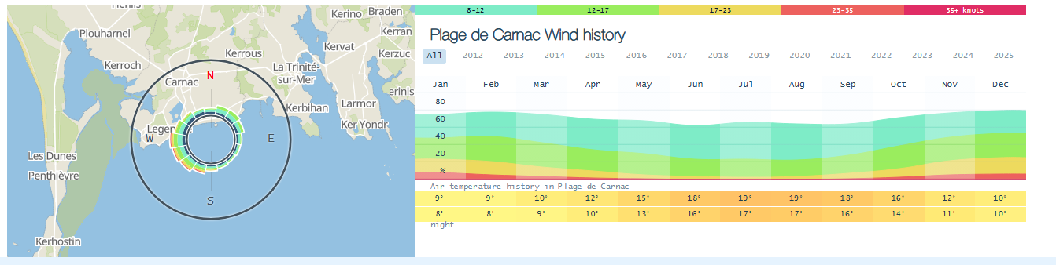
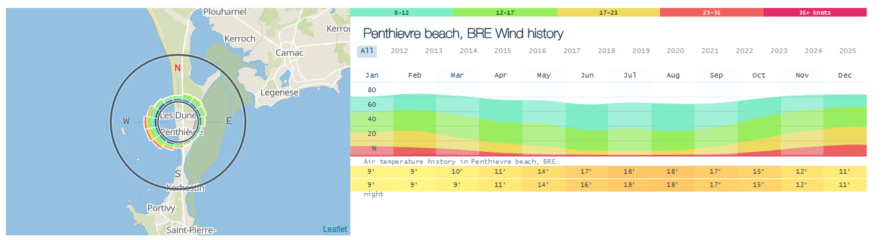

Tides times at Carnac with high tide in the afternoon and low coefficients
